Ideation Phase
Brainstorm & Idea Prioritization

Date | 03 January 2026
Team ID
Project Name | BookStore
Maximum Marks | 4 Marks

Brainstorm & Idea Prioritization :
Step-1: Team Gathering, Collaboration and Select the Problem Statement

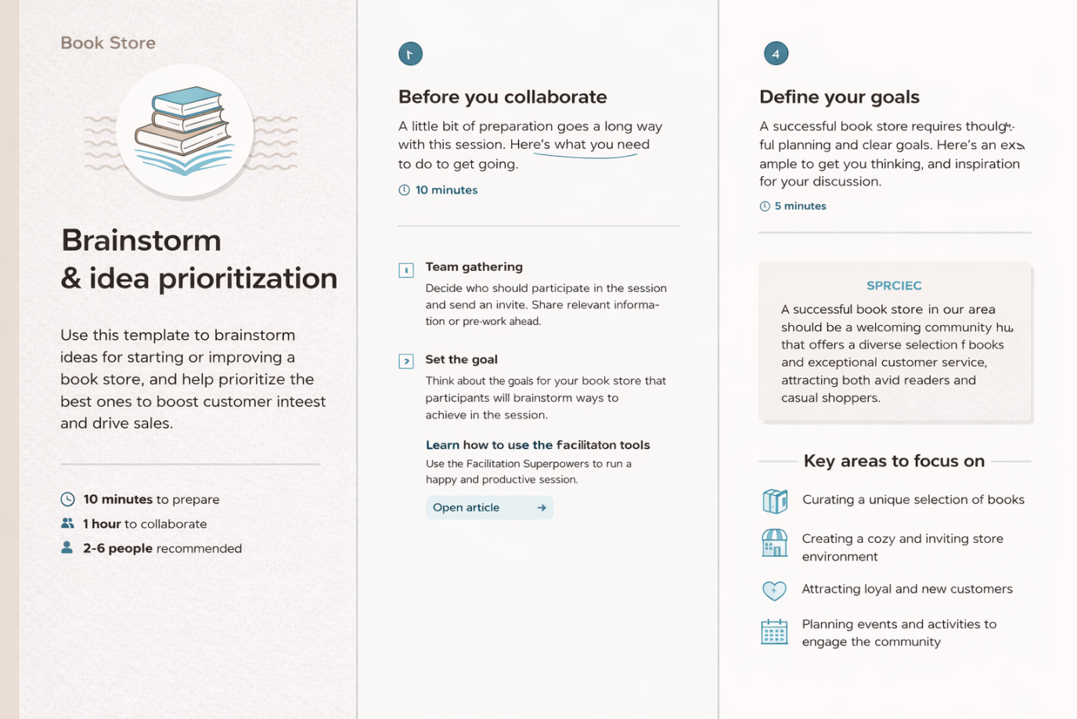

Step-2: Brainstorm, Idea Listing and Grouping
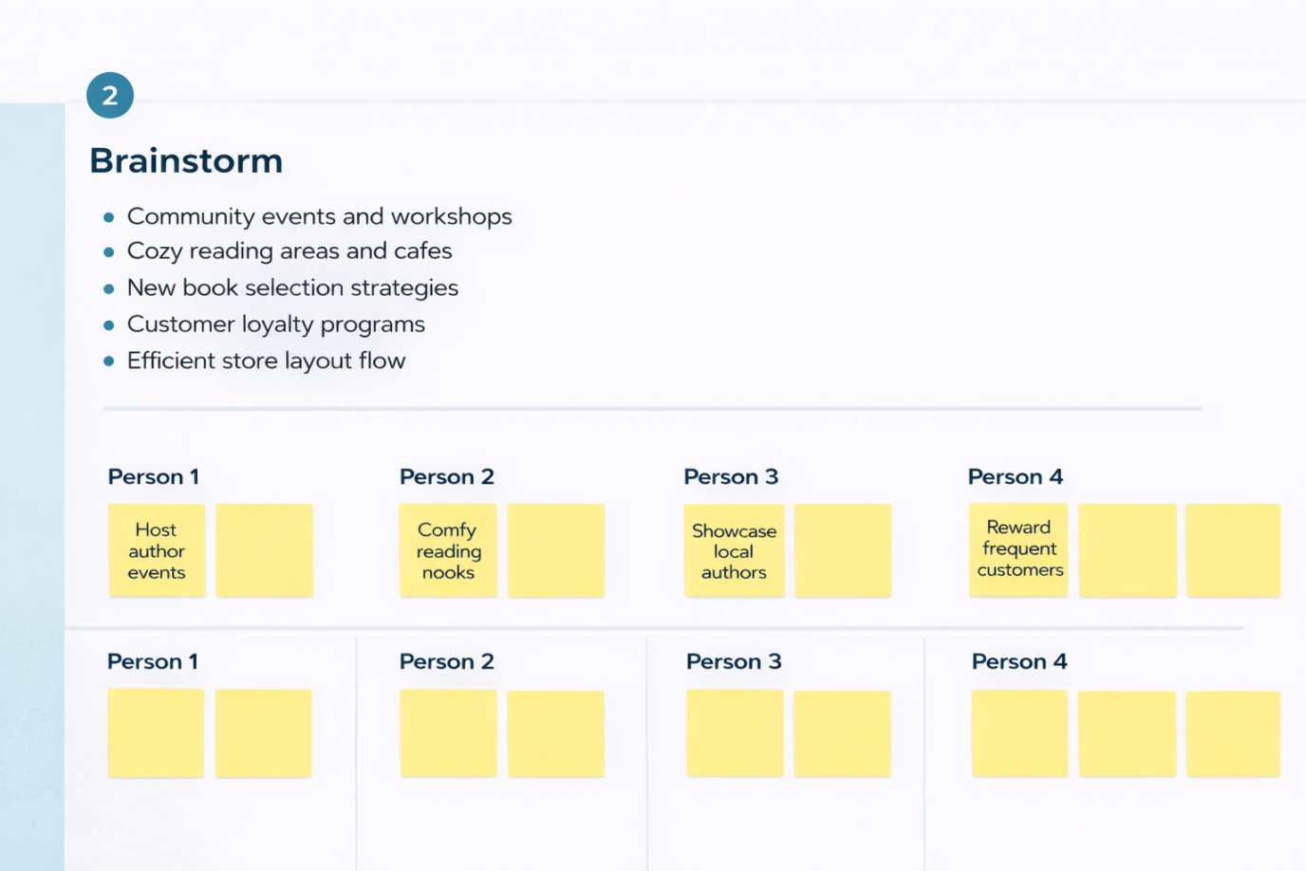
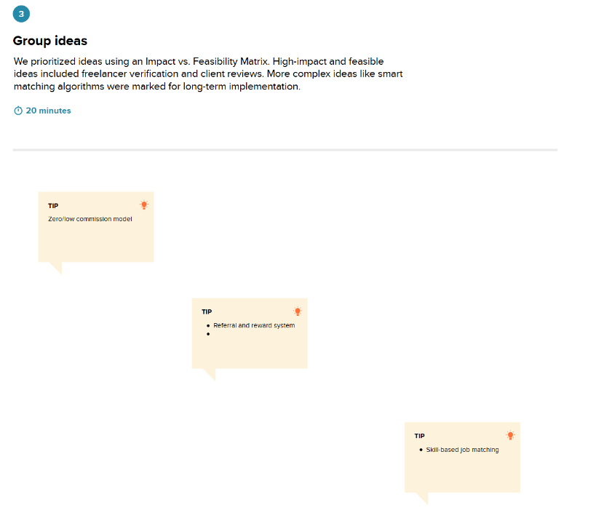

Step-3: Idea Prioritization
